Older Peoples Mental Health Community Teams

Information for people using our service

Your Named Worker is:
Named worker:
Team base:
Telephone number:

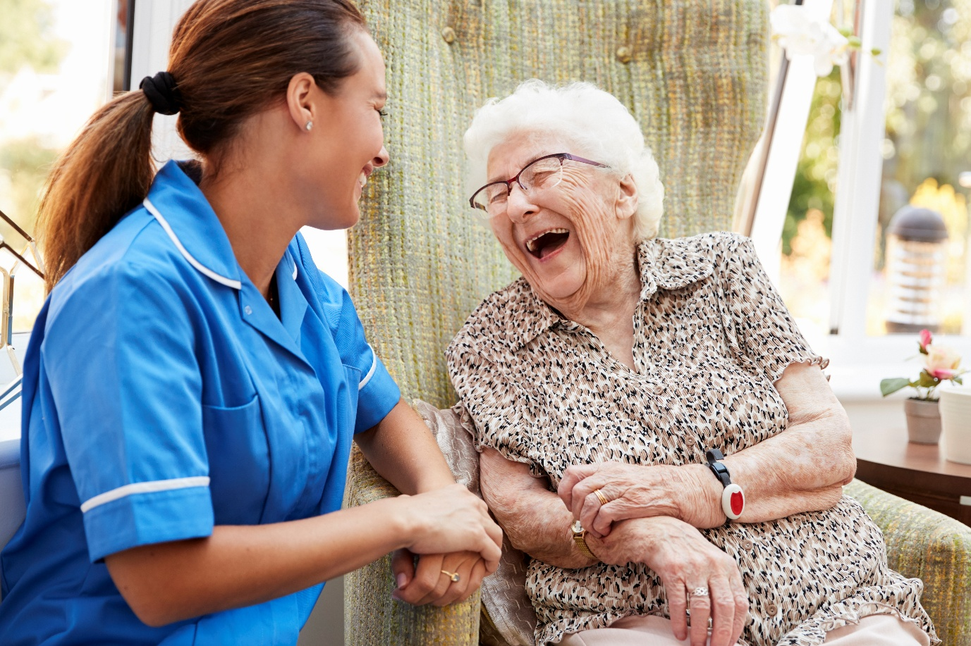

Who are we?
Our service is part of Humber Teaching NHS Foundation Trust, the organisation that provides mental health services across the Hull and East Riding area.
Our service works with people, and their families and carers across Hull and ER, who have mental health needs that cannot be fully met by their GP or other support services.
What will happen?
During your first appointment we will discuss your situation and make an assessment of your mental health needs.
This assessment is an important part of understanding the support that you might need from our service, and possibly others.
This first appointment can take between 1-2 hours on average. All plans of care (treatment plans) will be completed collaboratively with you, to ensure that we are meeting your individual needs.
You can choose to include your family, friends or a carer in this process.
You will also be allocated a Named Worker, who will act as a key point of contact.
Our staff have a wide variety of skills and experience and come from several different professional disciplines.
They include:
About our Community Mental Health Service
Community Mental Health Services are designed to support the changing mental health needs of individuals. We understand that there are many factors that can impact upon mental health which means that there are times when our mental health is good and there may be times when we need more support for our mental health, regardless of whether we have a diagnosis or not.
The help and support that we provide is tailored to individual circumstances. People generally remain in touch with our service for a limited period of time, and this is usually until immediate needs have been met, and the referred person is feeling more stable, and able to cope. For most people we provide short-term support that includes an assessment and possibly signposting and referral to other services.
Hull & East Riding Memory Assessment Service
The Hull & East Riding Memory Assessment Service is a Specialist Dementia Diagnosis Service for people over the age of 18.
Assessments are offered at a variety of locations across Hull & East Riding. Home visits are available to those who meet the Housebound Criteria. The assessment includes a memory assessment and the gathering of other information from the person and their supporters (where consent is given). This information may be about you, your lifestyle and life experiences and your health and any treatments you are receiving. Following diagnosis, a range of treatment interventions can be offered to the person living with Dementia and their supporters this will include referral to local support, the Alzheimer’s Society and the carers support agency for your area, for some people medication may be offered if appropriate.

Contact Details
Tel: 01482 336617
Email: hnf-tr.humbermemoryservice@nhs.net
Location
Hull Memory Clinic
39-41 Coltman Street
Hull HU3 2SG

Community Mental health Teams based across Hull and East Riding of Yorkshire.

We provide mental health assessment’s, interventions and care mainly for people over the age of 65. We work with people who have functional mental health needs (such as depression and anxiety) or organic needs (such as Dementia). We work together with public, private, and voluntary services to provide the best possible care. Clients are seen in clinics, in their own homes, residential or other care settings by community mental health practitioners and support workers. We also provide support and advice for carers and family members.
We work collaboratively with clients and carers and with statutory, private, and voluntary services. We provide assessment and interventions through an episode of care; treatment can include medicines management, evidence-based therapies, behaviour management advice and support for carers, such as education about diagnosis and prognosis.

Hull Integrated Care Team for Older People (HICTOP)

The Hull Integrated Care Team for Older People have the benefit of being an integrated team, including specialist mental health social workers. Having social workers based within HICTOP, reduces the need for referring service users to the Local Authority social services departments as HICTOP’s social workers can become involved as and when required which enables a collaborative approach between health and social care, providing holistic, person centred, and strengths-based Care Act Needs Assessments. The social workers within the team also provide support and guidance with other areas of social care such as housing and finances and co-work with the mental health nurses and occupational therapist where both roles are required to meet a person’s needs.
Contact details
Tel: 01482 335795

Location
Townend Court Block A
298 Cottingham Road
Hull
HU6 8QG

Older People's Community Mental Health Team (Beverley & Haltemprice)
Contact details.
Tel: 01482 344222
Location
College House
Willerby Hill
Willerby
HU10 6ED

Older people's community mental health team (Goole)
Contact details.
Tel: 01405 608288
Location
Bartholomew House
Boothferry Road
Goole
DN14 6AL

Older People's Community Mental Health Team Hedon
(Rosedale)
Contact details.
Tel: 01482 344400
Mental Health Response Service - Tel. 01482 301701
Location
Rosedale Community Unit
Preston Road
Hedon HU12 8JU

Older People’s Community Mental Health Team Bridlington and Driffield
(East House)
Contact details.
Tel: 01262 458220
Location
EAST HOUSE
38 St Johns Avenue,
Bridlington YO16 4NG

Mental Health Practitioners: Our Mental Health Practitioners are made up of various disciplines such as Mental Health Nurses (Including Nurse Prescribers & Non-Medical Prescribers), Associate nurse practitioners, Occupational Therapists, Physiotherapists and Social Workers with specialist mental health knowledge. We also have access to specialist dieticians. They will work with you and support with medications and treatment, your treatment/ care plan, will support you to meet your needs and work towards recovery and achieving your own goals. They will see you at home, or in an outpatient clinic at one of our team bases.
Assistant Practitioner: These are members of our team who have worked as Care Support Workers and developed skills in other areas including psychology, Cognitive Behavioural Therapy, some memory assessments and medication reviews – depending on your need.
Care Support Workers, Healthcare Support Workers, Occupational Therapy Assistants and Support Time Recovery Workers: These are members of staff who work in supportive roles under the guidance of our Mental Health Practitioners. They give practical assistance in the implementation of your individualised care plans and help you achieve your goals.
Psychiatrists: the psychiatrist's role is multifaceted, involving assessment, diagnosis, treatment planning, and medication management. They are medical doctors specialising in mental health, providing expertise in identifying and addressing various mental health conditions. Psychiatrists work collaboratively with other CMHT members to develop comprehensive care plans for individuals, ensuring a holistic approach to treatment.
Occupational Therapists: Occupational therapists see beyond diagnosis and limitations to hopes and aspirations. They assess the relationships between activities you complete every day, alongside the challenges you face in your environment. The occupational therapy team within the mental health service help you to focus on activities that lead to a sense of purpose and enhance your chance of recovery. Using occupational therapy, we enable you to lead your care, identify and plan achievable and realistic goals to support well-being and aid occupational performance. This can be achieved through developing skills, modifying tasks through graded activity and support with aids and adaptation to accommodate individual needs in your own environment and within the community. Older adults receive support to stay healthy, enhance wellbeing, remain safe, and socially connected for as long as possible

Physiotherapist: The aim of the Mental Health Physiotherapy team is to offer individual Patient Centred Care to people who, due to complex mental health problems, are unable to access mainstream Physiotherapy services.
We can provide initial assessments, treatments, and a plan of care to each patient, seeing them in their own homes or within Mental Health Inpatient units.
Associate Practitioner, APOT and APPT: The Assistant Practitioner Occupational Therapy (APOT) and the Assistant Practitioner Physiotherapy (APPT) will work as part of the Mental Health older people team, guided by the occupational therapist and physiotherapist. To deliver high-quality person-centred care to patients in their own homes, community and in Mental Health Inpatient units.
Both roles will include completing Holistic assessments, enabling client centred goal setting, completion of evidence-based interventions, reviewing and supporting with signposting and transferring of care. To support patients to improve and maintain their mental and physical wellbeing and to promote independence with activities of daily living.

Psychologists
A Psychologist in Older People’s services has received specialist training in ways of understanding and treating mental health problems. They offer specialised assessments and various psychological treatments and interventions for a range of different mental health and neurological problems that affect older people, to reduce distress and enhance wellbeing. This often includes working with the broader care system as well as with the individual. Further, Clinical Psychologists within the team can carry out specialist neuropsychological assessments to help investigate a range of neurological conditions such as dementia.

The teams are supported by a team of administrative staff who: manage the application of the processes of the organisation. This involves the efficient and effective organisation of people, information, and other resources to achieve organisational objectives. They are the personnel who handle scheduling, intake, and other administrative tasks. They ensure smooth operations and access to services, often being the first point of contact for patients and carers seeking assistance.

Confidentiality
Whatever you discuss with us is treated confidentially. We are required to send a written report to your family doctor, and you can obtain a copy.
Where appropriate, we will also talk to you about sharing information about you with other services and with your carer, family member, or friends.
Sharing information helps us to provide the very best service for you and we will always discuss it with you.
We keep records about your health and any treatment and care you receive.

Liaison Psychiatry for Older People
Older people's mental health assessment in hospital.

The liaison psychiatry service for older people is provided for:
older people (aged 65 years and over) who have a physical illness and co-existent psychiatric disorder (predominantly depression, delirium or dementia).
Older people with physical symptoms that have a psychological origin and physical illness and associated psychological or emotional problems.

Contact details.
Tel: 01482 675376
Location
Department of Psychological Medicine
(off Gladstone Street)
220-236 Anlaby Road
HULL HU3 2RW

Older People’s Intensive Home Treatment Teams
An alternative to inpatient admission
The intensive home care team provides an alternative treatment option to inpatient admission when someone has an increased mental health need. If the person needs inpatient admission, we work closely with the ward team and colleagues from other statutory and voluntary agencies to help them to go home as soon as possible.

Contact details.
Tel: 01482 344567
Location
Crisis Intervention Team for Older People
1st Floor Mill View
Castle Hill Hospital
Entrance 3
Castle Road
Cottingham HU16 5JQ

Acute Community Service /CMHTS for older people
The Acute Community Service is running a treatment program with the local Community Mental Health Teams (CMHTs) for Older People. The program is designed to help you to better understand your mental health. It is also designed to help build your coping skills so that you feel more able to manage your emotions moving forwards. At the end of the course, we will meet with you and your Care Co-ordinator to review how things are going and discuss next steps. This might include transferring your care back to your GP if things are going well or helping you to access other types of support in your local community. In some instances, it might involve setting a further treatment goal to work towards with your local CMHT.

The Crisis and Intervention Team for Older People

The Crisis and Intervention Team for Older People supports people aged over 65 who are experiencing a crisis with their mental health. This includes working with individuals who require intensive and frequent support to reduce risk, assessing their needs and providing short term intervention and treatment. We work with people who have a wide range of mental health difficulties, including depression, anxiety, psychosis and dementia.

Our team consists of Nurses, Nurse Prescribers, Health Care Assistants, Psychologists, Occupational Therapists, and Consultant Psychiatrists. We work 7 days a week, 8am – midnight.
We undertake a number of roles to support service users, carers and their families in the community, this may include:
- Taking an in-depth look at what may be beneficial for you by gaining a good understanding of your background and lifestyle
- Making tailored plans to suit your individual need
- Providing support to access medication and psychological interventions
- Signposting to other services that may be helpful to you
- Supporting leave and discharge from mental health hospitals
- Helping you to stay safe at home

The crisis team provides short-term intervention and support. When working with us, you can expect to receive ongoing support through other teams, such as your GP or Community Nurses.

Care Home Best Team

We are a team of mental health specialists working with people predominantly over the age of 65 in care home settings. We provide specialist assessment, treatment and review of people experiencing changes or concerns regarding their mental health and those requiring increased support.

The aim is to reduce distress for those experiencing mental health difficulties in care settings and improve quality of life.
To reduce the need for medication where appropriate.
To enable people to stay in their preferred care settings.
To reduce the need for restrictive interventions.
To provide training and improve carers confidence in understanding complex presentations and managing behaviours that may challenge.

Primary Care Mental Health Networks
Across the East Riding there are number of local Primary Care Mental Health Networks and Community Mental Health Teams working closely together to provide a range of support within local communities. They may provide support themselves, or through linking you in with a specialist team or with other groups and resources within your local community.
We aim to provide a range of support from GPs in Primary Care to our Primary Care Mental Health Networks and Community Mental Health Teams so that people can get the right support at the right time, preventing them from becoming more unwell.

Primary Care Mental Health Networks (PCMHNs)
“The service actually listens to me. They don't judge at all. They take the time to understand a person.” (Service User, Cygnet Primary Care Mental Health Network)
Primary Care Mental Health Networks are small teams of specialist mental health professionals who are able to help you with your mental health difficulties.

Mental Health Professionals that provide support within the PCMHN are…
They are an extension of the local Community Mental Health Team and work in close partnership with your GP surgery and the Local Authority providing primary care mental health provision.
Following a visit to your GP, if mental health support is required for mild or moderate difficulties, your GP may refer you to Let’s Talk (Hull), the Emotional Wellbeing Service (East Riding) for talking therapies or to your local Primary Care Mental Health Network.
You can also self refer by calling the Mental Health advice and support line on 0800 138 0990.
Your local Primary Care Mental Health Network can provide…
- Advice
- Guidance
- Support
- Treatment
- Signposting

Following an initial assessment from a mental health professional, you and a member of staff from your local PCMHN will work together to decide what kind of support you might need. This could inlude being signposted to a specialist service or organisation within the community that can best meet your needs, or you may receive 12 weeks of targetted support from a mental health professional within the PCMHN.

Contacts/Information
Click here for a list of other useful services - Support Services for you (humber.nhs.uk)
The Samaritans 24/7 service (Free call from landlines and mobile phones): 116 123. Text SHOUT to 85258
NHS Direct 24/7 service (non-emergency number):111
Alzheimer’s Society – Dementia support Mon to Weds: 9am – 8pm, Thurs and Fri: 9am – 5pm, Sat and Sun: 10am – 4pm 0330 150 3456
Age UK Advice Line 8am –7pm, 365 days a year: 0800 678 1602
Let’s Talk, Hull, call 01482 247111 or to book your assessment appointment online use www.letstalkhull.co.uk or text TALK to 61825.
Emotional Wellbeing Service, East Riding, call 01482 335451.
Emotional Wellbeing Service, Hull, call 01482 335000
Samaritans http://www.samaritans.org/ or Tel: 116 123
MIND http://heymind.org.uk/ or Tel: 0800 138 0990
Hull and East Yorkshire MIND, www.heymind.org.uk, 01482 240200
Crisis - Mental Health Crisis Intervention Team (humber.nhs.uk) or Support for adults experiencing a mental health crisis or urgent care need (humber.nhs.uk): 0800 138 0990
Carers Centre Hull, www.carersuk.org, 01482 225078
Rethink Carers Centre, www.rethink.org, 01482 679723.
Healthwatch, Hull, 01482 499038
Healthwatch, East Riding, 01482 334999

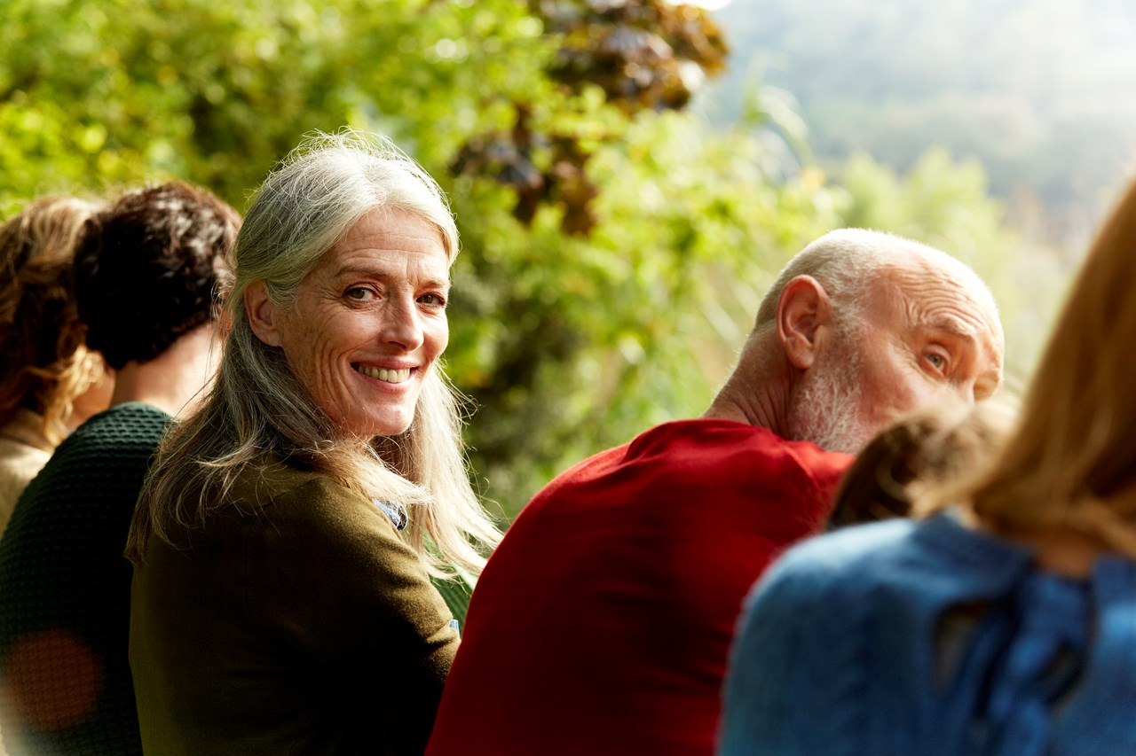

Link for able access to Humber sites
https://www.accessable.co.uk/humber-teaching-nhs-foundation-trust

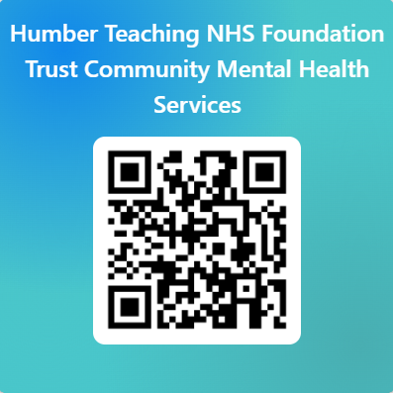
https://forms.office.com/pages/responsepage.aspx?id=slTDN7CF9UeyIge0jXdO43DXdSpH2eFPgzl1nRKl1TJUMUNCWEU5QUlFTjRUTzg0WEtFWkVGRVpWMiQlQCN0PWcu&origin=QRCode&route=shorturl

