Equality, Diversity and Inclusion Annual Report 2025

Contents:
Introduction by Karen Phillips, Associate Director of People and OD
1.0 Equality, diversity and inclusion opening statement
2.0 Introduction to Humber Teaching NHS Foundation Trust
3.0 Key achievements during the last 12 months
3.1 Patient and Carer Experience (PACE) Equalities Milestones
4.0 Governance structures
5.0 Statutory and mandatory duties – NHS standard contract
5.1 Implementation of the NHS Equality Delivery System (EDS22)
5.2 Implementation of the NHS Workforce Race Equality Standard (WRES)
5.3 Implementation of the NHS Workforce Disability Equality Standard (WDES)
5.4 Gender Pay Gap Report
5.5 NHS Accessible Information Standard (AIS)
5.6 Provision of a System for Delivery of Interpretation and Translation Services
6.0 National Staff Survey (NSS)
8.0 Appendices
- Appendix 1 - EDI data relating to the Yorkshire and Humber Region
- Appendix 2 – Workforce Demographics
- Appendix 3 – Progress on Objectives 2024/25 and New Objectives for 2025/26 and Links to Trust's Strategic Objectives

Introduction by Karen Phillips, Executive Director of People & OD
I am delighted to introduce this year’s Equality, Diversity and Inclusion (EDI) Annual Report for Humber Teaching NHS Foundation Trust.
This report reflects the incredible work undertaken across our Trust to create a more inclusive, compassionate, and equitable environment for our staff, patients, carers, and communities. It showcases the progress we’ve made, the challenges we continue to face, and the unwavering commitment of our people to drive meaningful change.
Over the past year, we have seen the embedding of our Respect and No Excuse for Abuse frameworks, the launch of our first Ethnicity Pay Gap analysis, and the continued growth of our staff networks. We’ve also made significant strides in workforce representation, strengthened our governance structures, and deepened our engagement with communities through co-production and collaboration.
EDI is not a standalone initiative—it is woven into the fabric of who we are and how we work. It is about ensuring that every individual feels seen, heard, and valued. It is about creating a culture where everyone can thrive, regardless of background, identity, or circumstance.
As we look ahead to 2025/26, we remain focused on delivering our EDI objectives, fulfilling our statutory duties, and continuing to listen, learn, and lead with compassion.

Thank you to everyone who has contributed to this important work. Together, we are building a Trust that truly reflects the diversity of the people we serve.
Karen Phillips, Executive Director of People and OD

Equality, diversity, and inclusion are at the heart of everything we do as a Trust. As the EDI Partner, I see these principles not just as values but as essential drivers of excellence in patient care and staff well-being. A truly inclusive environment ensures that every individual—regardless of their background, identity, or circumstances—feels valued, respected, and empowered to contribute their best.

By addressing disparities, fostering understanding, and celebrating diversity, we build trust with the communities we serve and create a workplace where innovation and compassion thrive. For us, EDI is not an add-on; it’s the foundation of delivering equitable, high-quality care and supporting a workforce that reflects the diversity of our society.
John Duncan, Equality, Diversity and Inclusion Partner

- Our Commitment to Equality, Diversity and Inclusion
Treating everyone fairly is a fundamental principle that the Trust upholds. We believe in Equality, Diversity, and Inclusion because we recognise that a diverse workforce offers numerous benefits. A diverse workforce brings fresh ideas, diverse backgrounds, and unique perspectives, which have the potential not only to enhance the experience for our staff but also to improve the quality of care for our patients, service users, and carers. As an organisation with a diverse workforce, we gain invaluable insights that help us enhance our efforts to promote workforce diversity.

Humber Teaching NHS Foundation Trust, as a public sector body, is governed by the Equality Act 2010 and the Public Sector Equality Duty (section 149 of the Equality Act 2010) in relation to its equality duties.

The general duties are:
- Eliminate unlawful discrimination, harassment, victimisation and other conduct prohibited by the Act.
- Advance equality of opportunity between people who share a protected characteristic and those who do not.
- Foster good relations between people who share a protected characteristic and those who do not.

Moving forward into 2025/26, the Trust and all of its key stakeholders will remain dedicated to prioritising and delivering key national priorities with unwavering focus. One crucial area of attention will be addressing the inequalities highlighted by the national staff survey. This commitment is an integral component of our ongoing journey as a compassionate and inclusive employer.
2.0 Introduction to Humber Teaching NHS Foundation Trust

Humber Teaching NHS Foundation Trust offers a comprehensive range of services across a broad geographical area.
The Trust employs approximately 3,700 staff across 82 sites at locations throughout five geographical areas: Hull, the East Riding of Yorkshire, Whitby, Scarborough and Ryedale. The Trust provides care to a population of 765,000 people of all ages who reside within an area exceeding 4,700 square kilometres, which encompasses areas of isolated rurality, dispersed major settlements, and pockets of significant deprivation.
As a teaching Trust, we work closely with our major academic partners, including Hull York Medical School and the University of Hull, as well as other educational establishments. This close working relationship enables us to nurture the future generation of doctors, nurses and other healthcare professionals. Our workforce is paramount to delivering high-quality care to our patients, and the organisation strives to be an employer of choice locally, offering long-term employment opportunities alongside structured personal and professional development.

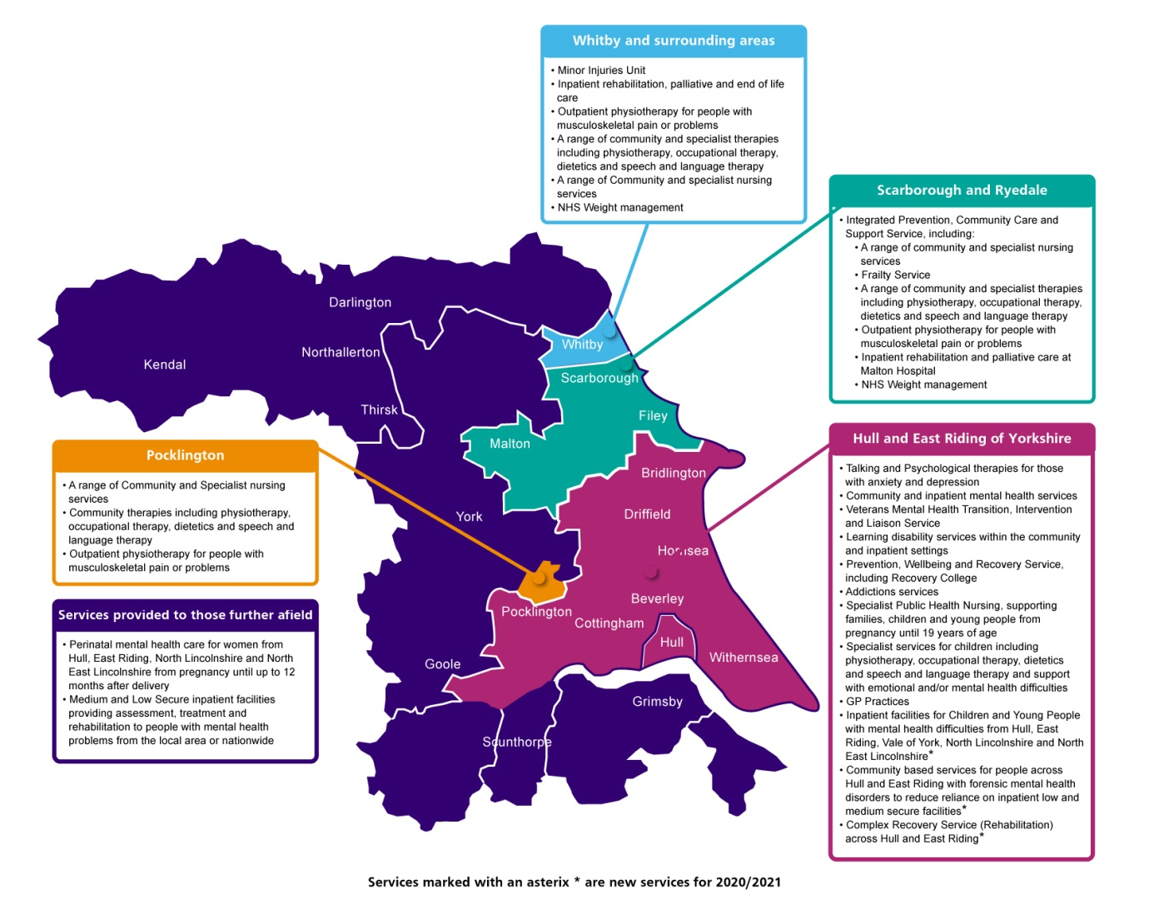

Our Strategic Aims
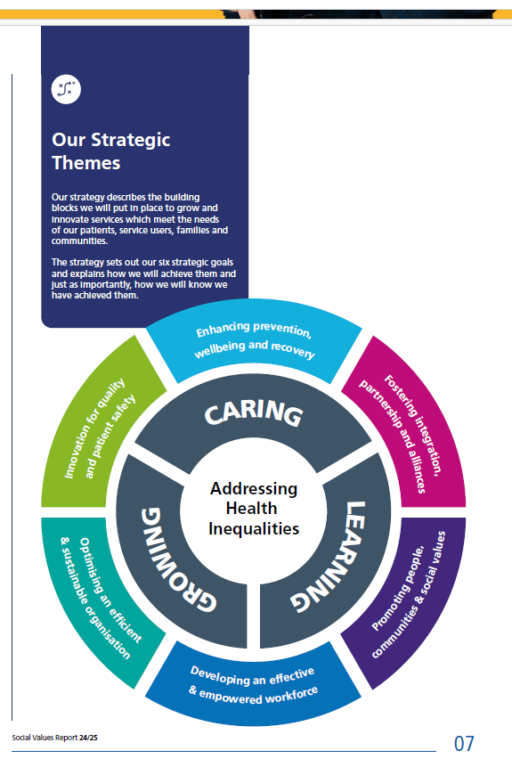
Humber Teaching NHS Foundation Trust's strategic objectives focus on delivering high-quality, inclusive healthcare services while addressing disparities and fostering equality. The table below demonstrates where our EDI for 2025/26, shown on page 32 links to the Trust’s Strategic Objectives:
Trust Strategic Objective | EDI Objective
Innovating for quality and patient safety | 4, 7, 13
Enhancing prevention, wellbeing and recovery | 3, 4, 8, 9
Fostering integration, partnerships and alliances | 2, 3, 6, 7, 8
Promoting people, communities and social values | 1, 2, 4, 5, 6, 8, 9, 10, 11, 12, 13
Developing an effective and empowered workforce | 1, 2, 3, 4, 5, 6, 8, 9, 10, 11, 12, 13
Optimising an efficient and sustainable organisation | 2, 3, 4, 5, 7, 10, 11, 12

The new Patient and Carer Experience Five-Year Forward Plan (2023-2028) came into effect, following Board ratification, in September 2023. The strategy defines how Humber Teaching NHS Foundation Trust will engage with people, listen and respond to their experiences so that we can improve patient and carer experience and satisfaction within our services.

Humber Teaching NHS Foundation Trust Workforce Demographics

The table below illustrates the continued progress in workforce representation over the past four years. Having a reliable and accurate workforce dataset ensures that the Trust can identify where action is needed to improve representation and better reflect the communities we serve.
Notably, the Trust has made significant progress since 2021 in improving representation in the workforce from a range of communities, including those with diverse heritages, disabilities, long-term conditions, and LGBTQ+ identities. This is further enhanced by the fact that not only has our diversity increased, but so has our workforce.

This demonstrates that our pragmatic response to the actions outlined in the Workforce Race Equality Standard and the Workforce Disability Equality Standard has yielded several successes. Similarly, our work on LGBT+ inclusion has also shown progress.

Year | % of  workforce  that is Diverse | % of  workforce  that is  disabled | % of  workforce  that is  LGBTQ+ | % of  workforce  that is female | % of  workforce  that is  part-time | % of  workforce  aged over 50
2025 | 8.99% | 9.9% | 4.75% | 79.07% | 33.94% | 34.67%
2024 | 7.19% | 9.14% | 4.50% | 79.34% | 33.43% | 34.54%
2023 | 6.22% | 8.19% | 3.92% | 79.17% | 33.37% | 34.65%
2022 | 5.85% | 7.66% | 4.0% | 79.25% | 34.44% | 35.14%
2021 | 4.73% | 6.66% | 3.0% | 78.4% | 43.0% | 37.0%

3.0 Key achievements during the last 12 months

Humber Teaching NHS Foundation Trust is committed to developing a diverse and inclusive workforce that attracts and engages talented individuals from all backgrounds. We want to be recognised as an organisation that embraces diversity and inclusion.

During the 2024/2025 period, the Trust introduced a range of initiatives to meet local equality objectives. It worked towards meeting the required standards within the Public Sector Equality Duty; which included:
Respect - The objective of the original Respect campaign, launched in November 2023, was in response to anecdotal feedback from our staff networks, with the key aim of increasing the reporting of bullying and harassment among staff. This has subsequently become business as usual in reporting. Our 2024 survey results show that the most statistically significant improvement (+6.89%) is for the question ‘the last time I or a colleague received bullying, harassment or discrimination, I or a colleague reported it’. As such, we can see the impact of our work on Respect in the staff survey, where we have addressed under-reporting and driven up the reporting of these incidents.
No Excuse for Abuse - In December 2024, the Trust launched the No Excuse for Abuse Framework toolkit. This was widely consulted with stakeholders and designed to support managers and staff when subjected to abuse by service users in their care. Since its launch, the toolkit was recognised as the QI Charter of the Month in December 2024 and has subsequently been reviewed and endorsed by UNISON, which found it to be comprehensive and proactive. We are adding their logo to associated posters and documentation.
NHS England EDI Improvement Plan - The Trust Board implemented the requirements of the six high-level NHSE EDI Improvement Plan actions. Actions to address the high impact were agreed upon through a Board development day and associated EMT papers. This is demonstrated by all board members having EDI objectives in their annual appraisals. Implementing an Ethnicity Pay Gap analysis and further embedding and operationalising the Respect and No Excuse for Abuse frameworks to address bullying, harassment, and discrimination. Regular assurance is provided to EMT and the Board through a biannual EDI Assurance report, which identifies progress made on the improvement plan.
Following an EDI Roundtable led by NHS Providers, which examined experiences of implementing the improvement plan, the EDI Policy Development Principal Lead from NHS England conducted a Best Practice Interview with the Trust's EDI Lead to develop an EDI Best Practice Case Study on our approach to implementing the NHSE EDI Improvement Plan. This will be shared nationally later in the year.
Changes in staff composition - Through EDI workstreams, including a deep dive analysis of recruitment by area through an EDI lens and initiatives aimed at reducing ‘unspecified’ entries in equality data within ESR, the Trust has seen a year-on-year improvement in workforce representation.

Ethnically diverse representation increased from 3.5% in 2019 to 8.99% in March 2025. Furthermore, our previous analysis of WRES data identified barriers to the representation of ethnically diverse staff in clinical and non-clinical roles at Band 7 and above. Over the past 12 months, we have seen a 14% improvement in this representation.

Similarly, we have seen a 20% improvement in the representation of disabled staff in clinical and non-clinical roles at band 8c and above, as well as an increase in disability representation across the workforce, with year-on-year improvements since 2019. The figure stood at 3.9% in 2019, rising to 10.05% as of March 2025.
Race Equity Training - Starting in March 2025, the team at Black Thrive Global facilitated two virtual sessions on race equity for ward staff and executives.
This training is designed to support our staff in understanding, actioning, and embedding the Culture of Care’s (CofC) Anti-racism Guiding Principle in our wards. It demonstrates how the Patient and Carer Race Equality Framework (PCREF) connects with the Culture of Care programme, transforming service access, experience, and outcomes for culturally and ethnically diverse service users and staff.
Several of our ward managers, EDI Lead, and PCREF Lead attended the training in March. Further training is scheduled to take place in May, and several of our executives will attend training tailored to senior leaders later in the year. This will support executive leaders in showcasing inpatient service improvements that meet PCREF requirements while implementing the CoC's race equity principle.
Ethnicity Pay Gap Analysis - The Trust conducted its first ethnicity pay gap analysis last year. The resulting report found no negative pay gaps between staff from ethnic minority backgrounds and their white colleagues.
Act Against Racism Charter - The Trust has met the Royal Society of Psychiatrists' Act Against Racism Charter. The campaign provides a framework of 15 actions for Trusts to address racism, developed with Medical Directors, the NHS Race and Health Observatory, and experts. The Executive Medical Director leads the initiative, supported by our EDI Lead. The Board receives regular updates through a biannual EDI assurance report.
Recruitment Deep Dive - A detailed recruitment report was created that applies an EDI perspective to our recruitment activities between April and October 2024, considering protected characteristics. Insights from this report were shared with HR Business Partners, who incorporate this information into their workforce planning meetings to address underrepresentation and to implement actions that support diverse recruitment strategies. The improving demographics of the Trust workforce are a testament to this collaborative approach.
NHS Rainbow Badge Accreditation Action Plan - Following review, the priority was to focus on the service area's confidence in supporting trans patients. Through a collaborative approach, we have seen the delivery of clinically developed trans training with lived experience to service areas, the introduction of a widely consulted policy supporting trans patients, and the development of an updated SOP for trans patients’ medical records.
Reducing Avoidable Harm Working Group – During the year, we established a working group to examine how the Trust can reduce avoidable harm in formal investigations by reviewing best practices in the NHS and implementing proportionate actions to address this through multi-stakeholder involvement.
Equality, Diversity, and Inclusion Event - This event was a well-attended exploration of the importance of equality, diversity, and inclusion (EDI) in our lives and health services, and an opportunity to co-produce the Patient and Carer Experience (PACE) EDI priorities for the next two years.

After a heartfelt welcome from Chief Executive Michele Moran, attendees were blown away by the Hull Visual Choir, who performed numbers such as ‘A Little Help From My Friends’, ‘Don’t Stop Me Now,’ and ‘Bring Me Sunshine,’ in British Sign Language. Their joy was infectious and got the event off to a very positive note! Following this, Sarah Regan, Residential Manager at the Hull & Yorkshire Deaf Centre, gave the audience an eye-opening insight into Deaf life, British Sign Language, and the challenges faced in day-to-day communication. She did this in both verbal English and British Sign Language. Everyone in the room improved their understanding of the needs of this distinct community.

Updates followed on EDI work for the workforce, as well as for patients and carers. This was followed by an outline of the Patient and Carer Race Equality Framework (PCREF), which guides all mental health providers in ensuring that anti-racism is embedded throughout the organisation and that this work is co-produced by those with relevant lived experience.

Attendees, including staff, patients, and other stakeholders, collaborated to develop our PACE EDI priorities for the period from 2025/26 to 2026-27.

Trust Chair Rt. Hon. Caroline Flint closed the event with some of her trademark wisdom.

Patient and Carer Race Equality Framework (PCREF)
The Trust has begun working on the Patient and Carer Race Equality Framework (PCREF), a national initiative aimed at supporting mental health service providers in improving racial equity. This is needed because national and international data show that both access to mental health services and the treatment people receive can vary by ethnicity.

Why is this important?
- People from racialised communities and ethnically and culturally diverse groups face barriers to accessing mental health services nationally, and their experiences in these services are likely to be worse than for the rest of the population.
- Black adults also have the lowest mental health treatment rate of any ethnic group, at 6% (compared to 13% in the White British group).
- Bangladeshi and Pakistani communities have poorer results using NHS services like Talking Therapies for anxiety and depression than non-racialised groups.

How will PCREF help?
The Patient and Carer Race Equality Framework has been co-produced nationally. Although the title refers to patients and carers, the framework also directly relates to staff and the wider community.

To ensure that all patients are treated appropriately, we will be co-producing and embedding concrete actions alongside people who have lived experience of mental health issues and their wider communities. Together, we can better understand how to improve our services for communities whose needs may not currently be met, thereby reducing racial inequalities within them.

How will it work?
The PCREF looks at the following key elements of improving services:

- Leadership and governance - Our Board will lead in establishing and monitoring concrete plans of action to reduce health inequalities.
- Data - New data on improvements in reducing health inequalities will be published, along with details on ethnicity in existing data collection.

- Feedback mechanisms - New, visible, and effective ways for patients and carers to provide feedback will be established, along with transparent processes for acting on and reporting that feedback.

Work carried out in 2024/25 has ensured that the appropriate leadership and governance are in place. We have developed an understanding of the reporting requirements, which has emphasised the need to ask all service users questions about their protected characteristics.
3.1 Patient and Carer Experience (PACE) Equalities Milestones

Over the past twelve months, the Trust undertook a wide range of initiatives to meet with Trust equality and diversity objectives to ensure the Trust works towards the Public Sector Equality Duty; these included:
- Panel volunteers continue to sit on interview panels across all services in the Trust to allow service users and members of the public to influence recruitment and selection decisions.
- Work continues to strengthen the collection of demographic data within a context of Electronic Patient Record implementation across the Trust.
- Work continues to identify carers and signpost them for support; the Carer’s Dashboard provides additional information at team and divisional level, and monthly prompts are sent to all divisions to access their team-level data.
- Virtual and face-to-face services were, and continue to be, hosted by the Trust Chaplain. These have included patients, carers, and other stakeholders such as representatives from organisations supporting veterans. Services have been held on Trust premises and within the community.
- The Trust Chaplain is a member of the Hull & East Riding Interfaith group, which also strengthens Trust multi-faith links with the community.
- The Trust co-production logo continues to identify an increasing amount of work produced with patients, service users, carers and individuals with lived experience. It is a great way to add value and recognition to the hard work and support that goes on behind the scenes to co-produce work and to showcase where co-production has taken place.
- Community links are strengthened, for example, by Trust involvement in the Peel Project Health Fair (August 2024), promoting the Humber Youth Action Group, Research, and access to Mental Health services. This was particularly pertinent, as it occurred very shortly after the riots in Hull, which had severely affected this area.
- The Humber Youth Action Group (HYAG) remains a valuable resource for the Trust as it shapes and co-produces services. Its support and input into the new Connect website, which provides a single, user-friendly digital home for the wide-ranging elements of our Children’s and Learning Disabilities services, have been a key success factor. The HYAG also enables participants to learn about the Trust, potential carers in the NHS, and to develop new skills and knowledge in a supportive environment.
- The Experts by Experience (EBE) initiative continues to shape service change. EbE are people with experience of using services as either a patient, service user or carer. Once registered on the EbE Bank, EBEs are remunerated for undertaking activities with the Trust.
- The Forensic Services division has responded to patient feedback to bring a stronger Equality, Diversity and Inclusion (EDI) ethos directly to patients. A team of patients and staff have identified the needs within the service and planned a range of events to meet them. This initiative was launched in March 2025 with a well-attended EDI Fair within the Humber Centre which welcomed patient groups, carers, the Recovery College, Patient & Carer Experience colleagues, representatives from Healthwatch (who amplify the patient voice), City Health Care Partnership and others to chat to stallholders and learn more about a range of topics.
- The Trust is participating in the national Culture of Care initiative, in which four of our inpatient wards across a range of services are piloting quality improvement projects in their areas. The Culture of Care teams co-produce these projects with patients, carers, and Experts by Experience, focusing on ensuring all services are fully Autism-informed, Trauma-informed, and operate within anti-racist principles, which include cultural competency.

4.0 Equality, Diversity and Inclusion Governance Structures
The Trust has governance, regulatory frameworks and mechanisms in place to ensure that assurance is provided in relation to the discharge of equality duties. The EDI governance structure reflects our approach to ensuring a clear leadership commitment to support the delivery of our EDI strategy. It reflects the important relationships and collaboration between key stakeholder groups, whose common purpose is to make sure that EDI is considered in all our work.
People and OD Committee
The purpose of the People and OD Committee is to provide a strategic overview and ensure assurance to the Trust Board that there is an effective system of governance and internal control across workforce and organisational development, supporting the Trust in delivering its strategic objectives and providing high-quality care. This includes Workforce, ED&I and staff health and wellbeing.
EDI Steering Group
The EDI Steering Group brings together key stakeholders in the Trust to ensure that Equality, Diversity, and Inclusion efforts are advanced in a structured manner. The group leads and facilitates the necessary changes regarding the workforce inclusion agenda, actively supporting the Trust’s objectives.
This group meets quarterly, is chaired by the Associate Director of People and OD, and is attended by staff network chairs and other key stakeholders, including representation from all service areas of the Trust. This group reports to the People and OD Committee and provides regular updates and assurance on progress against objectives.
Embedding EDI in Our Work - Roles and Responsibilities
Our Board
The Trust Board is our governing body. It is responsible for the overall control of our organisation, including agreeing on this report and holding the Executives to account for its delivery. Last year, we introduced EDI objectives into Board member appraisals to further embed EDI throughout the organisation. These objectives were reviewed in March 2025.
Executive Management Team
The Chief Executive and Executive Directors form the Trust Executive Management Team (EMT). Directors have the authority to establish the EDI priorities within their respective business areas. They are also accountable to the Chief Executive for making sure the resources are in place to deliver the EDI priorities. Directors are responsible for providing their teams with the support and understanding they need to deliver EDI through their work. Last year, we introduced EDI objectives into EMT member appraisals to further embed EDI throughout the organisation. These objectives were reviewed in March 2025.
Management and Line Managers
Managers and line managers are responsible for implementing the EDI strategy and for understanding and promoting the importance of EDI within their respective business areas. They must ensure that all staff are aware of and engaged with these priorities, and that they understand how our approach to EDI aligns with the overall Trust's vision and strategic plan.
All Employees
Everyone is responsible for making sure they:
- Uphold the equalities and human rights legislation.
- Treat all colleagues and patients with respect and civility.
- Maintain compliance with EDI mandatory training.
- Contribute to an inclusive working culture that celebrates the diversity of their colleagues and the people using our services.
- Everyone has a responsibility to ‘live’ our Humber values and to bring these to life through their work and interactions with other people both inside and outside of the organisation.
Patients, Service Users, and Carers
EDI is a regular agenda item at the Trust’s Patient and Carer Experience (PACE) forums. An annual update is presented to the Quality and Patient Safety (QPAS) group, the Organisational Delivery Group, the Executive Management Team, and the Quality Committee within the Patient and Carer Experience (including Complaints and Feedback) report.

Community Consultation through Networks

The Trust ensures decision-making regarding EDI is in consultation with the community through a range of local and regional networks, which include:
- Local groups such as the ICB-led Inclusion Academy,
- Regional groups such as the Yorkshire and Humber Regional E&D leads network
- Hull and East Riding LGBT+ forum
- Peel Street Project network
- Hull Sisters
- Hull Interfaith Group
- Trust forums including Patient and Carer Experience Forums, Veterans Forum and Humber Co-production Network
- Humber Staff Networks including: Race Equality, LGBTQ+ and Disability Staff Equality Networks

It is recognised that staff equality networks are an excellent mechanism through which the general duties of the Equality Act 2010 can be supported in relation to staff from the protected groups and other groups at potential risk of inequality.
The Trust currently has three established staff networks:
- LGBTQ+ staff network, known as the Rainbow Alliance, with the Head of Corporate Affairs acting as the executive sponsor.
- The Race Equality staff network, with the Executive Director of Nursing, Allied Health and Social Care Professionals acting as the executive sponsor.
- Humber Ability Group (for staff with long-term health conditions and Disabilities), with the Executive Director of Finance acting as the executive sponsor.

The importance of staff networks has been formally recognised at a national level and articulated in the NHS People Plan. Each of the Staff Networks has access to a substantial budget and administrative resources to support them. Terms of reference have been established to provide a framework for these networks and the delivery of their aims.

EDI Training
It is a statutory and mandatory requirement for all employees and workers at the Trust to complete the Health Education England E-learning Equality, Diversity and Human Rights Level 1 course every three years. This is a national-level course aligned with the Core Skills Training Framework (CSTF), which establishes an acceptable minimum standard of competence. As of March 2025, compliance with the training is 98%.
New Starters

EDI features prominently in the Corporate Induction programme to ensure that, from the outset, all new employees are aware of the Trust’s commitment to the EDI agenda. This includes an overview of how the Trust undertakes inclusion initiatives, our Trust workforce demographical data and an introduction to the Staff Networks.

5.0 Statutory and Mandatory Duties – NHS Standard Contract

5.1 Implementation of the NHS Equality Delivery System (EDS22)

Previously known as EDS2, a new template was introduced in 2023, referred to as EDS22. Completion of the EDS22 is a requirement of both NHS Commissioners and NHS Providers in the NHS Standard Contract. It is an annual requirement to upload data to the system, after which a summary report is generated.
EDS22 is a toolkit designed around three primary goals, and grades are given against each:

- Domain 1: Commissioned or provided services
- Domain 2: Workforce health and well-being
- Domain 3: Inclusive leadership
The EDS22 is implemented in a three-stage process:
- Self-assessment
- Peer-reviewed assessment
- Stakeholder-reviewed assessment

The Trust is given gradings against each of the primary goals each year. In summary, there are no undeveloped areas, no areas graded as developing, six areas graded as achieving, and five areas graded as excelling. The EDS22 is considered and agreed upon by the Trust Board each year.

5.2 Implementation of the NHS Workforce Race Equality Standard (WRES)

The Workforce Race Equality Standard (WRES) is designed to help NHS organisations understand and actively address differences in the experiences of staff from diverse communities and those of white staff. It ensures that the Trust evaluates the experiences of its diverse workforce and sets actions for improvement.
The WRES comprises nine indicators; indicators 1 – 4 are taken from the Trust’s HR data systems; indicators 5 – 8 are taken from the national NHS Staff Survey, and indicator 9 pertains to the Trust’s senior leadership.
The WRES provides a robust reporting framework and supports NHS organisations in addressing and closing any gaps through the development and implementation of action plans for improvement.
Summary of Progress during 2024/25:

The Trust has improved in all nine Workforce Race Equality Standard (WRES) indicators compared to the previous year's figures. Seven of these indicators have surpassed national comparison figures, highlighting two focus areas moving forward.

Areas for Assurance
- For WRES Indicator 1, which analyses the representation of ethnically diverse staff across the pay bands, we have seen a 14.47% improvement in ethnically diverse staff working in clinical and non-clinical roles of band seven and above. Similarly, we have seen an improvement in ethnically diverse representation across the workforce, with year-on-year improvements since 2019, when the figure was 3.5%, rising to 8.99% in March 2025.

- For WRES Indicator 2: The relative likelihood of staff being appointed from shortlisting, the Trust has a ratio of 0.78, indicating that ethnically diverse staff are likelier to be appointed following shortlisting. We can be assured that ethnically diverse staff are not disadvantaged in our recruitment processes.

- For WRES Indicator 3: Relative likelihood of staff entering a formal disciplinary investigation, we have seen the gap narrow significantly between ethnically diverse and White staff.

- For WRES indicator 4: Relative likelihood of staff accessing non-mandatory training and CPD, the Trust is demonstrating equality between ethnically diverse and White staff accessing non-mandatory training and CPD

- For WRES indicators 5 through 8, representing NSS responses, the Trust has improved on the previous year's figures in all four.
  - We have seen year-on-year improvement for three indicators since 2020.
  - In two of the four indicators, we have seen a significant narrowing of the gap between ethnically diverse and White staff and is the closest the figure has been to that of White colleagues since 2020.
  - We have observed an improvement in the number of ethnically diverse staff completing the NSS, increasing from 50 in 2020 to 152 in 2024.
- For WRES indicator 9: the percentage difference between the organisation’s Board voting membership and its overall workforce. With a figure of 11.1%, surpassing our workforce and local demographic representation, the Trust performs well against the national comparison figure of -10.9%.
Areas for Focus
- Despite seeing an improvement in WRES indicator 5, the percentage of ethnically diverse staff who have experienced harassment, bullying, or abuse from patients, relatives, or the public in the last 12 months is 33.55%, which is higher than the national figure of 31.64%.
- Despite seeing an improvement in WRES indicator 8, the percentage of ethnically diverse staff who have experienced discrimination from their manager, team leader, or colleagues in the last 12 months is 11.49%, significantly higher than it is for White staff at 5.21%
Action Plan for 2025/26

Nº | 2025/26 Objective
1 | Fulfil the requirements of the NHSE EDI Improvement plan and support the board to realise high-impact action 1. ​
2 | EDI Lead to work with the Culture & Workforce Project Lead, Mental Health, Learning Disabilities and Autism Sector Collaborative on the development of a systemwide Humber and North Yorkshire Reciprocal Mentoring Pilot programme
3 | Following the success of the Respect campaign, relaunch the Respect framework with new resources, including training video and posters, raising the profile for the ambitions of the work and further driving up a safe reporting culture.
4 | Build on the No Excuse for Abuse toolkit's success by better understanding the Datix data to provide benchmarking data, determine which areas have a higher prevalence of related incidents and drive work that provides bespoke support for those areas.
5 | Recognise that the No Excuse for Abuse toolkit is focused on post-incident support for staff and, in collaboration with stakeholders, develop methods to equip ward managers to be more proactive where they know there is a prevalence of abuse towards staff.
6 | Registered staff to attend Race Equity training provided by the Culture of Care national team in May and September to support transforming service access, experience and outcomes for culturally and ethnically diverse service users and staff.
7 | EDI Lead to represent workforce EDI at the newly formed Care, Culture and Equity Steering Group, a collaborative group bringing together the work of Culture of Care, Trauma Informed Care, Patient and Carer Race Equality Framework and Health Inequalities
8 | Continue to support the Executive Medical Director to realise the ambitions of the Act Against Racism Charter and embed inclusive practice across the organisation, providing regular assurance to EMT and the Board.

5.3 Implementation of the NHS Workforce Disability Equality Standard (WDES)
In 2019, NHS England launched the Workforce Race Disability Standard (WDES). Similar to the WRES, the WDES is mandated by the NHS Standard Contract and applies to all NHS Trusts and Foundation Trusts.
The WDES is a data-driven standard that utilises a series of ten metrics to enhance the experiences of Disabled staff in the NHS. All of the metrics draw from existing data sources (recruitment dataset, ESR, NHS Staff Survey, and local HR data), except one; metric 9b requires narrative evidence of actions taken, which will be written into the Trust’s WDES annual report.
The metrics have been developed to capture information related to the workplace and career experiences of staff with disabilities in the NHS. The following information provides insight into Humber Teaching NHS Foundation Trust’s current position against the Workforce Disability Equality Standard (WDES) Metrics. Humber Teaching NHS Foundation Trust has demonstrated several key improvements over the past 12 months, compared to other NHS Trusts.

Summary of Progress in 2024/25

The Trust has improved in seven out of ten Workforce Disability Equality Standard (WDES) indicators compared to the previous year's figures. Seven of these indicators have surpassed national comparison figures, highlighting areas of focus moving forward.

Areas for Assurance
- For WDES Indicator 1, which analyses the representation of disabled staff across the pay bands, we have seen a 20% improvement in disabled staff working in clinical and non-clinical roles of band 8c and above. Similarly, we have seen an improvement in disability representation across the workforce, with year-on-year improvements since 2019, when the figure was 3.9%, rising to 10.05% in March 2025.

- For WDES Indicator 2: The relative likelihood of staff being appointed from shortlisting, the Trust has a ratio of 1.09, indicating that disabled staff are not disadvantaged in our recruitment processes.
- For WDES indicators 4 through 10, representing 9 NSS responses, the Trust has improved on the previous year's figures in six.
  - We have seen a significant reduction in disabled staff experiencing bullying and harassment from patients.
  - A significant improvement in the percentage of disabled and non-disabled staff reporting incidents of bullying and harassment.
  - A continual improvement since 2020 for disabled staff who believe that their organisation provides equal opportunities for career progression or promotion.
  - A continual improvement since 2020 for disabled staff feeling pressure from their manager to come to work, despite not feeling well enough to perform their duties.
  - A continual improvement since 2020 for disabled staff reporting that their employer has made reasonable adjustment(s) to enable them to carry out their work.
  - An improvement in the number of disabled staff completing the NSS, increasing from 286 in 2020 to 566 in 2024.
- For WDES indicator 10: the percentage difference between the organisation’s Board voting membership and its overall workforce. A figure of 9.09% closely matches our workforce and local demographic representation of 10%.
Areas for Focus
- Experiencing harassment, bullying or abuse from other colleagues. Slightly down on the national figure and an increase from the previous year.
- Experiencing harassment, bullying or abuse from managers. Better than the national figure, but an increase from the previous year.
Action Plan for 2025/26
Nº | 2025/26 Objective
1 | Fulfil the requirements of the NHSE EDI Improvement Plan and support the board in realising high-impact action 1. ​
2 | EDI Lead to work with the Culture & Workforce Project Lead, Mental Health, Learning Disabilities and Autism Sector Collaborative on the development of a systemwide Humber and North Yorkshire Reciprocal Mentoring Pilot
3 | Following the success of the Respect campaign, relaunch the Respect framework with new resources, including training video and posters, raising the profile for the ambitions of the work and further driving up a safe reporting culture.
4 | Build on the No Excuse for Abuse toolkit's success by better understanding the Datix data to provide benchmarking data, determine which areas have a higher prevalence of related incidents and drive work that provides bespoke support for those areas.
5 | Recognise that the No Excuse for Abuse toolkit is focused on post-incident support for staff and, in collaboration with stakeholders, develop methods to equip ward managers to be more proactive where they know there is a prevalence of abuse towards staff.
6 | EDI Lead to represent workforce EDI at the newly formed Care, Culture and Equity Steering Group, a collaborative group bringing together the work of Culture of Care, Trauma Informed Care, Patient and Carer Race Equality Framework and Health Inequalities
7 | EDI Lead to work with local partners to realise the aims of the Disability Confident Leader Programme.

5.4 Gender Pay Gap Report

The Equality Act 2010 (Specific Duties and Public Authorities) Regulations 2017, which came into force on 31 March 2017, made it a statutory requirement for organisations with 250 or more employees to report their gender pay gap annually by 31 March, as of the previous 31 March.

The report must include:
• The mean and median gender pay gaps
• The mean and median gender bonus gaps
• The proportion of men and women who received bonuses
• The proportions of male and female employees in each pay quartile

The gender pay gap shows the difference in the average pay between all men and women in the workforce. The gender pay gap is different from equal pay. Equal pay is regarding pay differences between men and women who carry out the same, or similar, jobs or for work of equal value. It is unlawful to pay people unequally based on gender. It is possible to achieve pay equality while still having a significant gender pay gap.

On this basis, the Trust has a clear policy of paying employees equally for the same or equivalent work, regardless of their sex (or any other characteristic set out above), the Agenda for Change pay framework is designed to support NHS Trusts in ensuring NHS employees are paid equally and this is fully embedded within the Trust.

The Trust has a largely female workforce, like many other NHS organisations. At the time of the report, 79.08% of the workforce were female, and 20.92% were male.

Based on a snapshot date of 31 March 2024, the Trust has a mean gender pay gap of 9.84%. This represents a significant improvement from the previous year's figure of 12.4% and marks a year-on-year decrease since the first gender pay gap report in 2018.

The Trust compares favourably to the national mean pay gap figure for 2024, which stands at 18.1%, representing a 7.5% increase from the previous year.

The median gender pay gap is 0.56%, a significant improvement on the previous year's figure of 6%. The Trust compares well to the national median pay gap figure of 17.3%, a 3.2% increase from the prior year.

Areas for Assurance:
- The gender pay gap of 9.84% is the lowest the Trust has ever reported
- The median gender pay gap of 0.56% is also the lowest the Trust has ever reported
- The number of men in quartile 2 – the upper-lower quartile – has increased
- The number of men in quartile 4 – the upper-higher quartile – has decreased
- The Trust’s mean and median gender pay gaps are amongst the lowest in the system

Clinical Excellence Awards
The Clinical Excellence Awards (CEAs) were nationally recognised discretionary payments awarded to clinical colleagues who have contributed exceptional clinical skills and expertise to improving the quality of care in the NHS. The scheme has now ceased, and therefore, no further awards will be granted. The final CEA payment, which was equally distributed to all the qualifying medical staff, was paid before 31 March 2024. Still, existing awards remain, which affect 11 medical staff, and will continue to be reported in the following year.

The only people reported to have received bonus pay are medical staff who have received Clinical Excellence Awards. The bonus pay was distributed equally among 33 medical staff members, comprising 18 men and 15 women.

Addressing the Gender Pay Gap in 2025/26

Nº | Driver | Action
1 | Encouraging, promoting and supporting flexible working arrangements in senior roles | - Use the Carers Working group or peer Support Group to create an atmosphere where all staff feel valued and welcome, especially regarding caring responsibilities.
2 | Make senior jobs more accessible to women | - Promote flexible working to appeal more to men to increase the percentage of men that work less than full-time, encouraging equal sharing of caring responsibilities, reducing the stigma for men and reducing the number of women obliged to choose less than full-time working to accommodate caring responsibilities.  - Continue to leverage PROUD leadership and Alumni development programmes to develop staff and increase the appointment of a more balanced senior workforce.
3 | Succession planning | - Further embed and build upon the succession planning model to provide balance in the promotion, succession planning and development opportunities for females into more senior roles and making lower banded NHS roles appealing to men

5.5 NHS Accessible Information Standard (AIS)

The AIS came into effect for all NHS organisations in July 2016. The Standard aims to ensure that patients, service users, carers, and parents with information or communication needs related to a disability, impairment, or sensory loss receive information in a format they can understand and any communication support they need to enable them to access services appropriately.
The Trust has Accessible Information Standard guidance, which outlines the general steps to be taken to ensure that any information and communication support needs related to disability, impairment, or sensory loss of patients/service users and/or their parents/carers are met. This includes needs for:
- Information in a ‘non-standard’, alternative or specific format
- Use of specific or alternative contact methods
- Arrangement of support from a communication professional (eg a British Sign Language Interpreter or a deafblind manual interpreter); and
- Support to communicate in a different or particular way or to use communication aids (eg to lip-read or use a hearing aid).
This guidance document outlines the Trust’s obligations under the NHS Accessible Information Standard and explains how it intends to achieve compliance with the Standard.

During the initial assessment, clinicians identify if a patient, service user, or carer has additional communication needs. The information is captured within the patient record to inform teams of any communication needs. An alert is placed on the patient’s record and is visible to clinicians.

In December 2018, the Trust purchased Reachdeck (formerly known as Browsealoud) software for the website. Reachdeck is a solution for making information accessible to patients, service users and carers with learning difficulties, dyslexia, mild visual impairments and those with English as a second language. The website can now be translated into 99 languages and read aloud in 40 of the most commonly spoken languages in the world. Any of the website content can be converted into an audio file and listened to offline. Also, distractions can be blocked or removed from the page, allowing the individual to focus on the most important information.

The Trust has strengthened the Brand Centre by introducing guidance on writing Accessible Information, designing patient information and offering information in alternative formats.

The Trust has access to Healthwatch Read Right panels (Hull Healthwatch and East Riding Healthwatch), which provide feedback on our patient information.

The Trust Learning Disability (LD) Service has access to an information sheet that includes hints and tips for making information accessible, and the service also has a subscription to Widgit. The community and inpatient LD staff have access to Speech and Language Therapy Services, who can advise on specific accessible information for a patient-centred approach.

5.6 Interpretation and Translation Services

The Trust has access to several organisations that provide interpreter and translation services to support individuals accessing our services who have difficulty hearing, seeing, or understanding a particular language. The three key providers used by the Trust are Hull City Council who provides services to our patients in the Hull and East Riding area, The Big Word for individuals living in the Whitby, Scarborough and Ryedale region and Language Line who provides video interpreters to the teams who have the highest volume of patients who speak languages other than English as their first language.

Work has been undertaken to understand better the needs of people for whom English is not their first language. As a result, the Trust is working with neighbouring Trusts to improve our collective interpretation and translation offer.

6.0 NHS National Staff Survey (NSS)

In the 2024 Trust National Staff Survey (NSS), the response rate was 56%, which was the same as the previous year. The median response rate for the benchmark group was 54%.
The NSS responses are considered in each of the EDI reports, as addressed in section 5 of this report. Indicators and metrics in the WRES and WDES take data from the NSS. In 2021, the NSS questions were aligned to the NHS People Promise.
The People Promise outlines, in the words of our NHS staff, the things that would most improve their working experience.
The Trust’s score against each of the seven elements of the People Promise is outlined below alongside the two key themes, staff engagement and morale, that remained from the previous NSS. The results of the 2024 staff survey demonstrate the Trust scores higher than national comparison figures in all people promise themes.

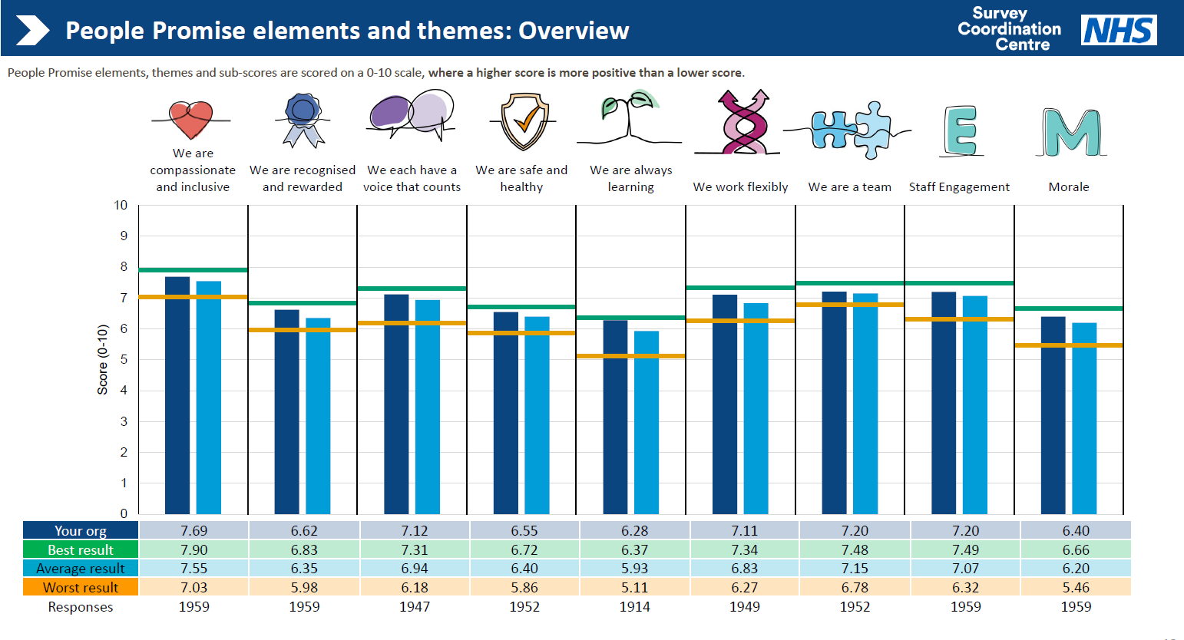
With the People Promise theme ‘We are compassionate and inclusive,’, the following infographics show the Trust's scores in summary:
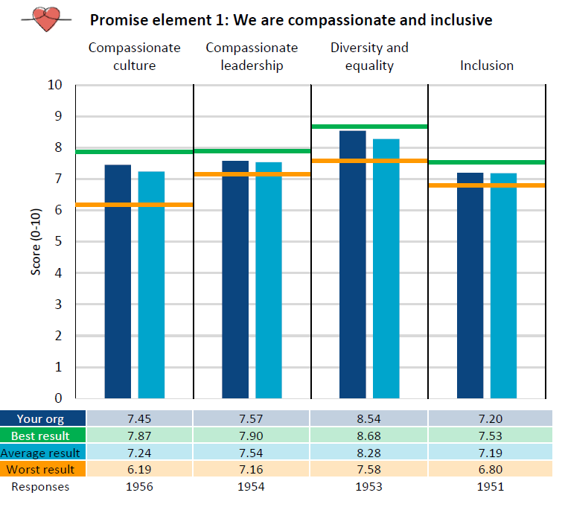
Areas of Focus arising from the NSS

Highest focus areas, these are questions deteriorating on 2023 Trust scores and worse than the benchmark group:
- Q6a I feel that my role makes a difference to patients / service users.
- Q7h I feel valued by my team.
- Q7i I feel a strong personal attachment to my team.

Other key focus areas, these questions deteriorating on 2023 Trust scores but better than the benchmark group:
- Q16a In the last 12 months, have you personally experienced discrimination at work from patients/service users, their relatives or other members of the public?
- Q16b In the last 12 months, have you personally experienced discrimination at work from a manager/team leader or other colleagues?
- Q8b The people I work with are understanding and kind to one another.
- Q8c The people I work with are polite and treat each other with respect.

The NSS responses have been analysed at the division/directorate level, with local divisional ownership of bespoke actions and delivery. Each division is held accountable for its NSS scores via accountability reviews and objective setting.

Appendix 1 - EDI data relating to the Yorkshire and Humber Region

In East Riding of Yorkshire, the population size has increased by 2.4%, from around 334,200 in 2011 to 342,200 in 2021.
In the 2021 Census, we have seen minor changes to the local demographics.

Ethnic identity across the East Riding of Yorkshire in 2021
Ethnic origin | Percentage | % Change since 2011
Asian, Asian British or Asian Welsh | 1.1 | +0.2
Black, Black British, Black Welsh, Caribbean or African | 0.3 | +0.1
Mixed or multiple ethnic groups | 0.9 | +0.2
White | 97.3 | -0.7
Other ethnic groups | 0.3 | +0.2

Gender Identity of people over the age of 16 across East Riding of Yorkshire in 2021
Gender identity | Percentage | % Change since 2011
Gender identity the same as their sex registered at birth | 94.62 | Not measured in 2011
a gender identity different from their sex registered at birth | 0.29 | Not measured in 2011
Did not answer | 5.09 | Not measured in 2011

Sexual orientation of people over the age of 16 across East Riding of Yorkshire in 2021
Sexual orientation | Percentage | % Change since 2011
Straight or heterosexual | 91.22 | Not measured in 2011
Lesbian, gay, bisexual, or other (LGB+) | 2.01 | Not measured in 2011
Did not answer | 6.77 | Not measured in 2011

Religion of people across East Riding of Yorkshire in 2021
Religion | Percentage | % Change since 2011
No Religion | 39.1 | +15.7
Christian | 53.3 | -14.7
Buddhist | 0.3 | 0
Hindu | 0.1 | 0
Jewish | 0.1 | 0
Muslim | 0.6 | +0.2
Sikh | 0.1 | 0
Other | 0.4 | +0.2
Not answered | 6 | -1.3

Disability of people across East Riding of Yorkshire in 2021
Disability | Percentage | % Change since 2011
Disabled under the equality act: day-to-day activities limited a lot | 6.7 | -1.4
disabled under the equality act: day-to-day activities limited a little | 10 | +0.3
No disabled | 83.3 | +1.1

Age of people across East Riding of Yorkshire in 2021
Age | Percentage | % Change since 2011
aged 15 years and under | 15.8 | -0.9
aged 16 to 64 years | 57.8 | -4.2
aged 65 years and over | 26.4 | +5.1

Sex of people across East Riding of Yorkshire in 2021
Sex | Percentage | % Change since 2011
Female | 51 | -0.2
Male | 49 | +0.2

Appendix 2 – Workforce Demographics

The Trust has experienced a year-on-year increase in the number of underrepresented communities represented at the Trust. The table below provides a breakdown of current representation by area and Trust wide as an organisation.

Division | % from minority ethnic groups | % with Disability | % from LGBTQ+ community | % that is Female | % that is part-time | % aged over 50
Children's & Learning Disability | 6.10% | 8.61% | 4.14% | 87.47% | 39.22% | 32.46%
Community & Primary Care | 6.46% | 8.37% | 3.04% | 86.50% | 46.77% | 40.30%
Forensic Services | 16.34% | 8.95% | 3.50% | 60.70% | 17.90% | 33.46%
Mental Health Planned | 6.43% | 13.06% | 6.24% | 82.65% | 32.94% | 35.28%
Mental Health Unplanned | 13.63% | 11.33% | 5.25% | 76.03% | 22.33% | 27.75%
Chief Executive Officer | 6.45% | 0.00% | 3.23% | 67.74% | 41.94% | 51.61%
Chief Operating Officer | 8.00% | 12.00% | 8.00% | 68.00% | 16.00% | 44.00%
Finance | 5.68% | 7.67% | 2.56% | 61.08% | 46.88% | 51.70%
Workforce & OD | 2.63% | 11.84% | 7.89% | 76.32% | 28.95% | 27.63%
Medical | 20.00% | 10.77% | 8.72% | 77.44% | 18.46% | 14.87%
Nursing and Quality | 1.67% | 20.00% | 10.00% | 88.33% | 26.67% | 45.00%
Trustwide | 8.76% | 9.90% | 4.75% | 79.07% | 33.94% | 34.67%

Appendix 3 – Progress on Objectives 2024/25

Patient, Service Users and Carer Equality Objectives 2024/25

These objectives were agreed upon at a workshop held in May 2023, where patients, service users, carers, staff, and partner organisations participated in group work to share what matters most to them with Equality, Diversity, and Inclusion. Based on the workshop feedback, the following priorities were identified for the Trust to focus on during the period 2023-2025.

Priorities | Outcome | Progress Over the Past Twelve Months
- To strengthen patient demographic data collection to tailor care that meets individual needs. | An enhanced approach to deliver bespoke, tailored care to meet individual needs. | - The importance of this has been reinforced at a range of Trust forums and meetings, in the context of ethnicity data to inform Patient and Carer Race Equality Framework reporting, and in the context of addressing Health Inequalities.  - The staff intranet Health Inequalities pages include tips for staff on using data, including Trust data, to explore health inequalities. Future updates to the pages will include explicit reference to using demographic data as the data quality improves.  - The implementation of new patient electronic records across the Trust will facilitate greater compliance in collecting and reporting data, thanks to improved templates and renewed training.
- To further enhance our faith offering to ensure inclusivity. | A strengthened offer to accommodate individuals’ religious practices. | - The Trust booklet Caring For People of Different Faiths has been printed in physical format, with support from Health Stars. This has allowed distribution to groups of people who may have limited digital access.  It has been well-received at several events, including the Forensics Services EDI Fair.  - The Trust Chaplain continues to host services across the year, including Easter, Armistice Day and the Trust’s Christmas Carol Service.  - The Trust Chaplain and Race Equality Network Chair have both joined the Hull and East Yorkshire Interfaith Group.  - Some planned activities with partner organisations were affected by re-election restrictions, so they were unable to go ahead.
- To continue to build and sustain relationships with our diverse communities to fully understand the challenges people face and how we can support them in overcoming them. | A culture where relationships with our diverse communities are embedded and sustained. | - The Peel Street project has welcomed Trust staff to its Ladies Befriending Group, and to its Health Fair in August 2024.  - Trust representatives attended the community meeting held in Spring Bank Community Centre to discuss the impact of the riots with a mixture of elected officials, Voluntary Sector organisations, faith and other community leaders.  - A member of the PACE Team discussed a range of issues with community members at the Humber All Nations Alliance, and further discussions are planned.
- To introduce cultural celebration weeks to educate and support people to understand cultural differences. | A greater understanding of the cultural differences, including beliefs, behaviours and practices unique to ethnicity and race. | - The Culture of Care work and the PCREF are raising awareness of the importance of this understanding.  - The Trust Chaplain has been exploring the possibilities of podcasts as a resource and will be starting to record these in 2025/6. These will be available via the Recovery College.  - Some planned activities with partner organisations were affected by re-election restrictions, so they were unable to go ahead.

Progress Against Workforce Equality Objectives 2024/25
The table below details last year's actions and their current progress. While the following actions are complete for this year, many will continue to have an ongoing focus, moving forward.
Nº | Objective | Progress
1 | Fulfil the requirements of the NHSE EDI Improvement plan and support the board to realise high-impact action 1. ​ | Complete for 2024/25 appraisal window.
2 | Utilise the July 2024 Trust Non-Executive Director recruitment window as an opportunity to diversify the Board further. The EDI Lead will represent staff (in the capacity of Staff Governor) on the NED recruitment stakeholder panel. | Complete - Two new Non-Executive Directors were recruited, and the appointments supported diversifying the Board through female representation.
3 | Following the success of the Respect campaign, embed the Respect framework as a business-as-usual practice, raising the profile of the work's ambitions and further driving up a safe reporting culture. | Complete - The Respect campaign has seen a demonstrable impact and has been embedded as business as usual.
4 | Consult with stakeholders on the ‘No Excuse for Abuse’ task and finish the group on the guidance framework that seeks to address patient-to-staff bullying, harassment and aggression from patients. Further see this launched and embedded by March 2025. | Complete—The consultation was completed, and the toolkit was launched in December 2024.
5 | EDI Lead will attend the newly established People & OD working group to examine harm caused by formal investigations process and implement proportionate actions to address via multi stakeholder involvement. | Complete—In July 2024, a working group was established with the goals of Reducing Avoidable Harm and developing a restorative, Just Culture for employee relations procedures.
6 | EDI Lead to attend the newly established People & OD staff experience working group, which will examine issues of belonging and implement proportionate actions to address via multi-stakeholder involvement. | Complete—Established in May 2024, the working group has highlighted priorities and submitted recommendations to the senior management team.
7 | EDI lead to work with the Executive Medical Director to realise the ambitions of the Act Against Racism Charter and embed inclusive practice across the organisation, providing regular assurance to EMT and the Board. | Complete—The Trust has met the Act Against Racism Charter, a multi-year initiative aimed at addressing bullying, harassment, and discrimination against ethnically diverse medical staff.
8 | Realise the ambitions of the Rainbow Badge Accreditation action plan provided by the LGBT Foundation and embedded across the organisation by March 2025. | Complete—clinically developed trans training for service areas, revised trans inclusive policies and SOPS
9 | Implement the requirements of the Disability Confident Leader programme to achieve improved status by March 2025. | Ongoing—Working with CHCP to ratify Disability Confident Leader application

Patient, Service Users and Carer Equality Objectives 2025/27

These objectives were agreed upon at a workshop held in May 2025, where patients, service users, carers, staff, and partner organisations participated in group work to share what matters most to them with Equality, Diversity, and Inclusion. Attendees included staff, patients, and other stakeholders who collaborated to develop our PACE EDI priorities for 2025/26 to 2026-27.

Nº | Objective
1 | Demonstrate how the Trust incorporates feedback and co-production throughout its work, with additional use of “you said, we did”
2 | Increase co-production ethos to deliver service improvements and other quality improvements, through active listening and co-production with people with lived experience and Experts by Experience, alongside other stakeholders and staff.
3 | Inclusive trauma-informed policies and specific training to be available for both staff and patients.

Workforce Equality Objectives 2025/26

Nº | Driver | 2025/26 Objective
1 | EDI Improvement Plan | Fulfil the requirements of the NHSE EDI Improvement plan and support the board to realise high-impact action 1. ​
2 | WRES  WDES | EDI Lead to work with the Culture & Workforce Project Lead, Mental Health, Learning Disabilities and Autism Sector Collaborative on the development of a systemwide Humber and North Yorkshire Reciprocal Mentoring Pilot programme
3 | NSS | Following the success of the Respect campaign, relaunch the Respect framework with new resources, including training video and posters, raising the profile for the ambitions of the work and further driving up a safe reporting culture.
4 | NSS | Build on the No Excuse for Abuse toolkit's success by better understanding the Datix data to provide benchmarking data, determine which areas have a higher prevalence of related incidents and drive work that provides bespoke support for those areas.
5 | NSS | Recognise that the No Excuse for Abuse toolkit is focused on post-incident support for staff and, in collaboration with stakeholders, develop methods to equip ward managers to be more proactive where they know there is a prevalence of abuse towards staff.
6 | WRES | Registered staff to attend Race Equity training provided by the Culture of Care national team in May and September to support transforming service access, experience and outcomes for culturally and ethnically diverse service users and staff.
7 | WRES  WDES | EDI Lead to represent workforce EDI at the newly formed Care, Culture and Equity Steering Group, a collaborative group bringing together the work of Culture of Care, Trauma Informed Care, Patient and Carer Race Equality Framework and Health Inequalities
8 | WRES | Continue to support the Executive Medical Director to realise the ambitions of the Act Against Racism Charter and embed inclusive practice across the organisation, providing regular assurance to EMT and the Board.
9 | WDES | EDI Lead to work with local partners to realise the aims of the Disability Confident Leader Programme.
10 | GPG | Encouraging, promoting and supporting flexible working arrangements in senior roles
11 | GPG | Make senior jobs more accessible to women
12 | GPG | Further embed and build upon the succession planning model to provide balance in promoting succession planning, and development opportunities for females into more senior roles, and make lower-banded NHS roles more appealing to men.
13 | National | Deliver on relevant areas of the Supreme Court Judgement Action plan, ensuring the Trust responds to compliance and mitigates against risk, while maintaining a compassionate and sensitive approach to initiating any changes.

