RECOLLECT RESEARCH OPPORTUNITY - £60 worth of vouchers for taking part!
Research Opportunity: Recovery Colleges Characterisation and Testing 2 (RECOLLECT 2): Exploring the impact of Recovery Colleges on student outcomes and service use.
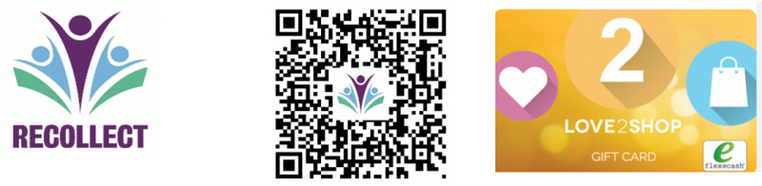
- Are you a recently enrolled Recovery College student who has attended no more than 1 course or workshop?
- Are you aged 18 or over?
- Are you accessing local secondary NHS mental health services (e.g. a community mental health team, assertive outreach team, etc.) or currently on the waiting list?
The RECOLLECT team are looking for help. We want to explore how Recovery Colleges might benefit those that use them.

What would it involve?
Completing 4 questionnaires over 12 months. The questionnaires take under an hour to complete and ask about the following topics: quality of life, recovery, hope, resilience, social inclusion, social networks, service use, your wellbeing, your goals, and how you feel about your Recovery College.

What’s in it for me?
- £15 voucher for each questionnaire completed (£60 in total).’
- The findings may have many possible direct / indirect benefits for Recovery College staff / students in the future, such as helping to inform future service provision.

Please click the link below to register your interest:
https://kings.onlinesurveys.ac.uk/expression-of-interest-form

Or to find out more, please click the link below:
https://www.researchintorecovery.com/recollect-national-study/
We now have a promotional video that explains the RECOLLECT project and what to expect from participating, it can be accessed here:https://bit.ly/41jXEP5.
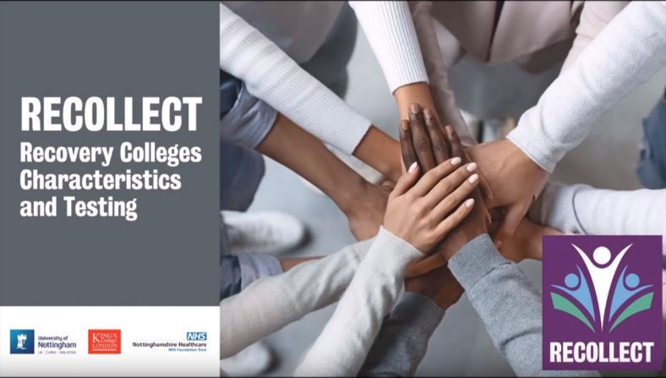
If you have any questions or require more information about this project, please contact: recollect@kcl.ac.uk

